CSCI 6314

Financial Management

Stocks and Bonds

1. Select 6 stocks that you like, and place it in a spreadsheet. Assume you bought 100 shares of each (mix dividend/non-dividend). Follow it for 2 days and calculate daily gains/loss in each stock and give a grand total of gains or loss in the spreadsheet. Explain how dividend would have change your outcome provided you happened to hold the stock before the ex-dividend date.

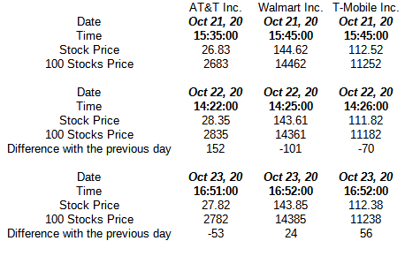

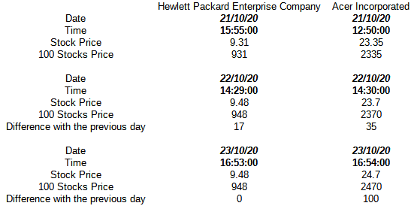

Total value of stock in day 1: 35244$

Total value of stock in day 2: 35412$

Total value of stock in day 3: 35506$

Income after day 2: 168$

Income after day 3: 94$

**Total income: 264$**

The case that if the stocks are got before the ex-dividend date, the buyer gets an income, while the stocks are got on or after the ex-dividend date, the seller gets an income. Usually, the ex-dividend day is one day before the record date.

1. Explain how you could sell options and mitigate your losses.

a) More time to the expiration, higher the premium of the option.

b) If the intrinsic value (the difference between strike price and stock price) is high, the premium of the option is also higher.

c) Knowing the decline rate per day (time decay) before expiration.

d) Checking the volatility of market.

Knowing these factors and selling the options in time allows either to get some profit or to reduce losses.

1. Explain How bond works. How one could earn interest from bond? At maturation how much principle would you get? If you sell before maturation how could you gain or lose value? What is a zero coupon bond and how does it work?

While you get the bond, the company takes the obligation to pay you the value back the face value at the maturity day. The buyer of the bond got an income by the interest (coupon) for a year. For example, if the bond’s face value is 1500$, and the coupon is 5%, it means that for each year, the income is 75$. It means that at maturation, the minimum value to get is the face value+number of years*coupon: in our case, at least 1500$+10*75$=2250$, because bonds are for at least 10 years. It is important to know that the buyer might get all principle only after reaching the maturity.

In the case if the bond is sold before maturity, the amount that the ex-holder gets is dependent on the

a) the commission rate or the broker “markdown”.

b) the price of the bond, which is reversely dependent on the interest rate. In other words, if the coupon falls, the price of the bond rises, and vice versa.

Zero coupon bond is the bond without an interest, but its price is lower than the face value. In the maturity date, the buyer gets the face value, which allows to get an income.